Invitation

During Dutch Design Week we will open Kazerne to the public.
Besides the regular openings hours we invite you to the
• press breakfast on Monday the 21st of October at 10 am

On behalf of Stichting ter behoud van Klein Paradijs,
Annemoon Geurts and Koen Rijnbeek

––––––––––––––––––––––––––––––––––––––––––––––––––––––––––––––––––––––––––

Press release_October 16th 2013
For immediate release

––––––––––––––––––––––––––––––––––––––––––––––––––––––––––––––––––––––––––

New cultural hotspot in the city centre of Eindhoven
Kazerne completely open to the public

During Dutch Design Week (DDW) the heritage Kazerne will be open to the public for the first time in many many years. A new, and at the same time historical hotspot in the city centre of Eindhoven, with over 2.500 square meter of contemporary design and two temporary restaurants. The presentation during DDW is the long-awaited launch of the permanent platform for the creative industries in design city of Eindhoven. From the 19th till the 27th of October Kazerne will be open daily from 11 am till 11 pm. Entry, free of charge.

Two expo restaurants, two chefs: Severijn and Kunis
In the former theatre Edwin Severijn will cook his full evening Dutch Design Dinners surrounded by haute design. With this he builds on the successful pop-up expo restaurant Eat Drink Design.
New is the à la carte Loods restaurant. Think of robust pasta, a salad or a three-course dinner for 35 euros, while seated on chairs by Maarten Baas, next to work of for example, by Kiki van Eijk and Joost van Bleiswijk. Initiator Annemoon Geurts: ‘Ronald Kunis, former chef of restaurant De Kas Amsterdam and River Café London, takes on a new 10-day challenge. We are very proud that he is willing to join us on this adventure and are enourmously curious how food and design lovers will react to his modern, vegetable based Mediterranean style’.
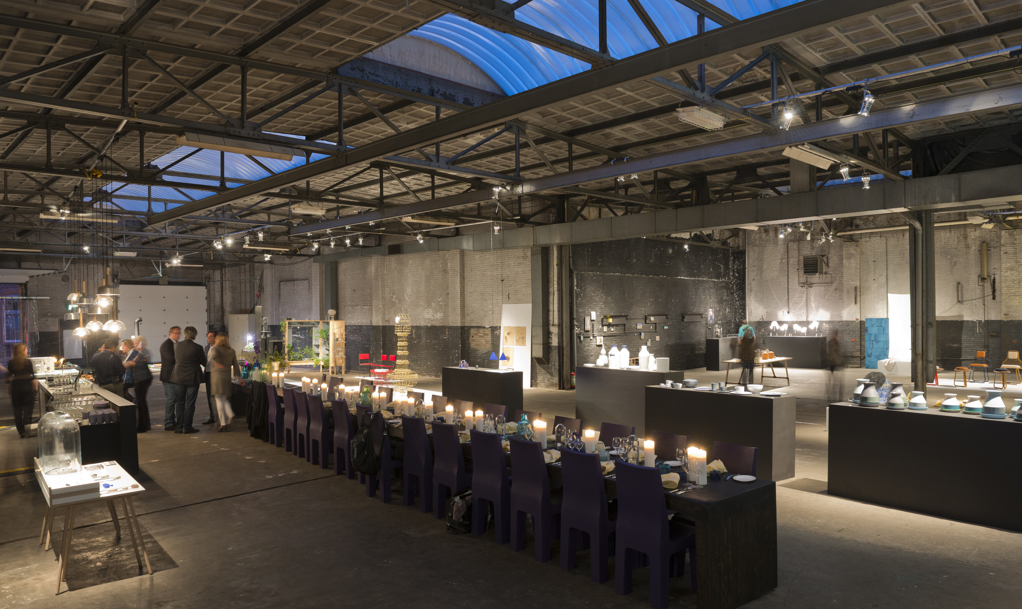
Modern design by new and established talent
During DDW the heritage Kazerne will be filled with contemporary design. Everywhere on this heritage there will be exhibitions. In the two contemporary restaurants, work will be shown from about 40 international top talents including (Dutch) firsts of BCXSY for the Japanese Inframince, Maarten Baptist, Nienke Sybrandy and Dick van Hoff for Thomas Eyck. In addition to this, Château de la Resle launches a new design label in the former coach house including work of Roderick Vos and the Intuïtiefabriek. In the former military police barracks at the Grote Berg, Glamcult and concept store You Are Here present Modebelofte 2013. Weltevree will fill the courtyard with outdoor furniture and stoves on which Kunis and Severijn will also cook.

New: Kazerne Lab
During Dutch Design Week the first Lab Projects will be presented to the public. Thanks to Stichting DOEN, artists, designers and other creatives will put their heads together leading into new insights on current issues. With their renewed ideas and thoughts they provide current social, cultural and economical questions of inspiration, new perspectives and answers.
Geurts: ‘This may sound very high-flown, however it is meant in a purely practical way. Designers Boaz Cohen and Sayaka Yamamoto (BCXSY) work together with the clients of day care centre Twinkelbel on new possibilities for their ceramic products. In addition to that, a study about new finance and construction organisation models, for the re-use of heritage like Kazerne will be presented. Joost van Bleiswijk will ask the question ‘How is it possible that people destroy their own enviremont?’ Finally, on Wednesday the 22nd at 18.00 pm, Nienke Sybrandy talks to HAS Den Bosch and Philips about her project Desktoop, a desk drawer built as a green house using LED lighting. Sybrandy explores the concept ‘true-to-nature’. After DDW these 4 projects will be developed in more detail and some new ones will be started on.

About Kazerne
The new life of the heritage, the exhibitions and the lab are initiatives by Annemoon Geurts and Koen Rijnbeek of design studio Moon/en/co. Kazerne promises to be a hotspot for inspiration, encounter and for good food and drinks. Geurts: ‘After DDW the storehouse part of the building closes temporarily due to rebuilding, this, thanks to the many participants such as, the Dutch VSBfonds. This means, not only that for this part of the re-use promised requirements are secured, but also recognition on a national level. The former property will remain open as a gallery. This monumental part of the heritage will be rebuilt as soon as the storehouse is finished. For this we are still looking for possible co-creators’. You can find more about information concerning this on www.kazerne.com.

---
Note for the editor, not for publication:
For more information, images and a personal illustration, please contact Annemoon Geurts, 040-2366196 or annemoon@kazerne.com.

From the 19th of October on images can be downloaded from
http://www.eatdrinkdesign.nl/nl/press/downloads/2013

