PRESS RELEASE October 15th 2012 (see also http://www.eatdrinkdesign.nl/press)

Preview international platform for the creative industries in Eindhoven
EAT DRINK DESIGN @ Kazerne & Loods

Just imagine: historic barracks of the military constabulary and a municipal storehouse in the centre of Eindhoven; cultural heritage that deserves a new destination. An exhibition of established and new top talents, with topical design, prototypes and firsts. Food and drink that stimulate all senses. Memorable meetings at the long table. Those are the ingredients of the 6th edition of EAT DRINK DESIGN at Dutch Design Week 2012. A 10-day preview for a permanent version of the pop-up exhibition with restaurant plus. Visit the exhibition during the day, free of charge. Come and taste espressos and truffles, bubbly and oysters. And enjoy a very special Dutch Design dinner in the evening.

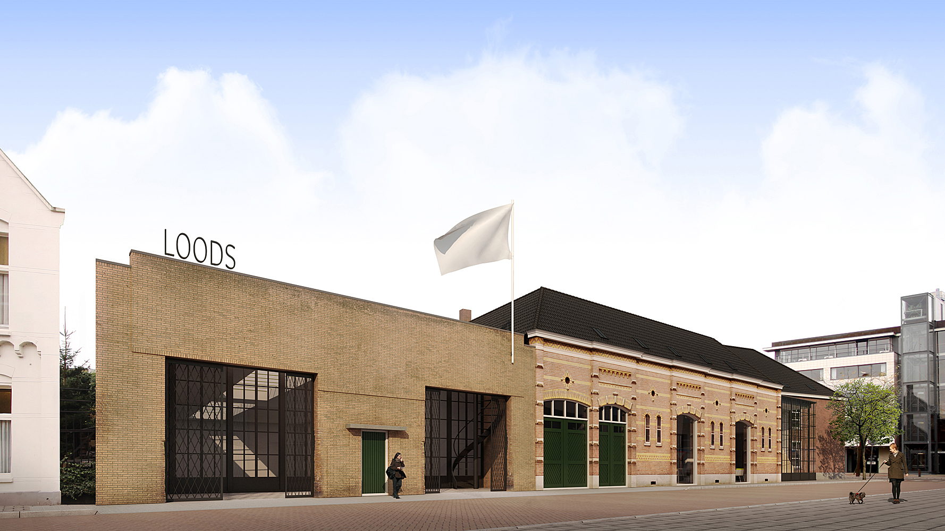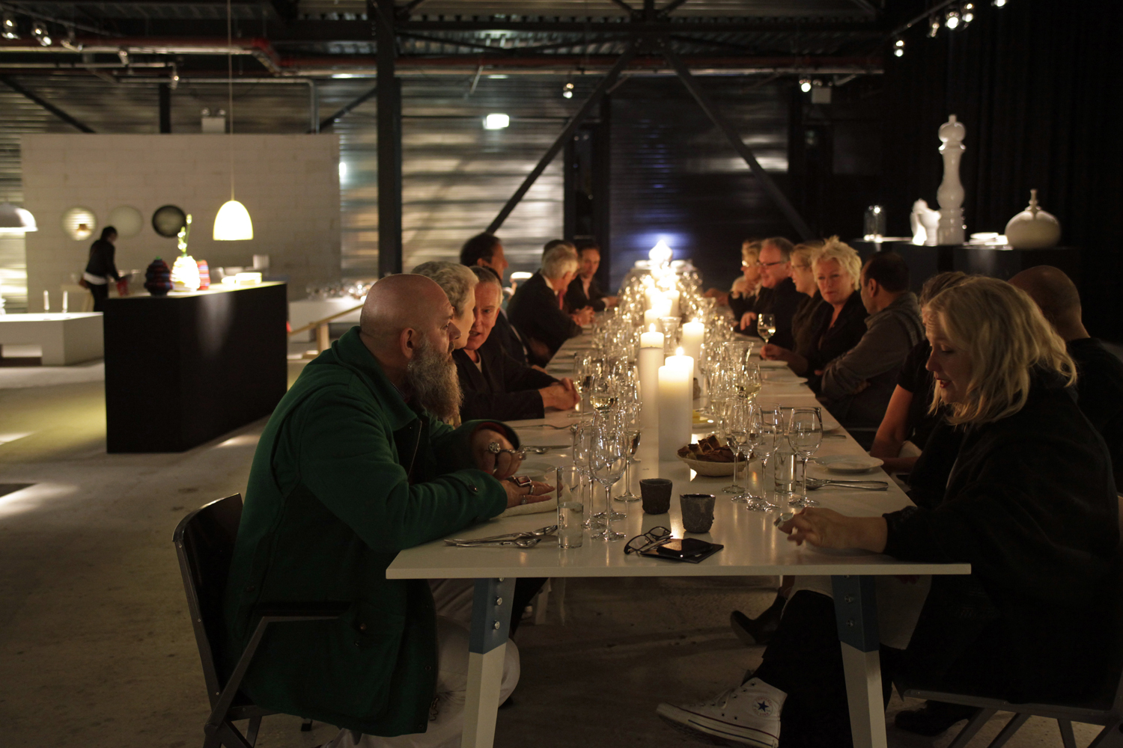
Preview Kazerne & Loods Dutch Design Diner at a previous edition (foto Lisa Klappe)

international platform for the creative industries
With Kazerne & Loods, Eindhoven will have another unique concept. A special, historic building where meeting up, exhibitions, eating, drinking, working, relaxation and sleeping are moulded into a memorable experience. The ultimate place to be for creative and business networks. From information worker to CEO, from own-account worker to client, from family to passer-by. "Creative Suites represents more than just the hospitality industry", says Annemoon Geurts, the promoter along with Koen Rijnbeek. "It represents inspiration, unexpected meetings, stimulating conversation and activities that inspire business. Because profits from the hospitality side are used for new exhibitions, projects and pop-ups."

Crowd funding
The former barracks and storehouse have stood more or less empty for more than 30 years. "Surely we must be able to find more enthusiastic people", the promoters thought. "People and businesses that love the unique cultural heritage and/or our concept. That is why the independent foundation Stichting ter behoud van Klein Paradijs is looking for loans in Euros, hours and products, in order to restore the cultural heritage and to start the substantive programme. Everyone we've talked to is enthusiastic. We're doing well with the crowd funding, but we're not quite there yet. The only way to do this is together."

Pop up exposition and restaurant
Pop-up exhibition with restaurant Eat Drink Design reveals a bit, for now. Annemoon Geurts: "It's exciting to set up a first exhibition in a space that we've been working with on paper for so long. With nearly 50 designers (with a striking number of duos, like Ontwerpduo and Daphna Laurens) it is impossible to give all the magnificent work the attention it deserves in just a couple of words. I'd like to refer to the designers that have been around since the first edition in 2006, such as Joost van Bleiswijk, Kiki van Eijk and Nienke Sybrandy. Maarten Baptist will present glass objects that can be used to prepare dishes in an innovative way. There will be firsts from Kranen/Gille, Ontwerpduo and Sander Lucas, among others. We Make Carpets will have a carpet made of every-day objects, especially for this room. Remarkable is the amount of work with a Delftware Theme, translated into new user objects. And I'm looking forward to the meetings at the six metre-long tables by VanJoost, when everyone is enjoying the meals prepared by Sot-l’y-laisse for instance on plates from Arian Brekveld for Royal Delft or in glasses from Van Eijk and Van Der Lubbe for Imperfectdesign."

Eat Drink Design @ Kazerne & Loods
Paradijslaan 8, 5611 KN Eindhoven, on the route between Design Academy and Designhuis.

Pop-up exhibition with restaurant during Dutch Design Week, 20 - 28 October 2012
11:00 - 20:00 Exposition (free admission)
11:00 - 18:00 Espresso’s & bubbles
19:00 - 00:00 Dutch Design Dinner

Phone: +31 (0)40 23 66 196
E-mail: info@eatdrinkdesign.nl

Please take a look at www.eatdrinkdesign.nl, www.kazerne.com and/or visit Eat Drink Design @ Kazerne & Loods.

Note for the editor
For enquiries, visual materials or interview requests please contact:
Annemoon Geurts: +3140 2364351 / +316 22529413 / info@eatdrinkdesign.nl / www.eatdrinkdesign.nl

Visual materials
By mentioning Eat Drink Design and the photographers name, free of rights high-res images are available on www.eatdrinkdesign.nl/press.

As from Friday October 19th new images are available.

Saturday October 23th 15:30 - 17:00 you are cordially invited to the opening bubble!

EAT DRINK DESIGN CONCEPT
Annemoon Geurts, Koen Rijnbeek (Moon/en/co) & Edwin Severijn (Sot-l'y-laisse)

CURATOR
Annemoon Geurts

DESIGNERS
Maarten Baptist / BCXSY / Bernotat & Borstlap / Joost van Bleiswijk / Brekveld, Van Eijk & Van der Lubbe, Imperfectdesign / Arian Brekveld, Chris Koens, Damian O'Sullivan, Royal Delft / Lio de Bruin & Sjoerd Ebberink / DTile / Kiki van Eijk / Germans Ermics / Thomas Eurlings / Grondvormen / Dick van Hoff, Weltevree / Richard Hutten, NGispen / Idiots / vanJoost / Chris Kabel / Lisa Klappe / Kranen/Gille / Klaas Kuiken & Dieter Volkers / Daphna Laurens / Manon Leblanc / Alexa Lixfeld / Sander Lucas / Alissia Melka-Teichroew, Rollout / Ontwerpduo / Alexander Pelikan / Marieke Peters / Bas van Raay / Maaike Roozenburg / Nienke Sybrandy / Sjoerd Vroonland / Jeroen Wand / We Make Carpets

